Computer Networks 1
Lab 1

Network Devices

Student Name:Vuong Le Huy

Student No.:1652252

I. Objectives:

- Get to know basic network devices
- Understand functions of network devices
- Able to connect different network devices together to form a simple network

II. Content

1. Get to know network devices:

- Network Interface Card (NIC)
- Cables
- Hub
- Switches
- Routers
- Access Points
- Modems

2. Understanding functions of network devices

a. Network Interface Card (NIC)

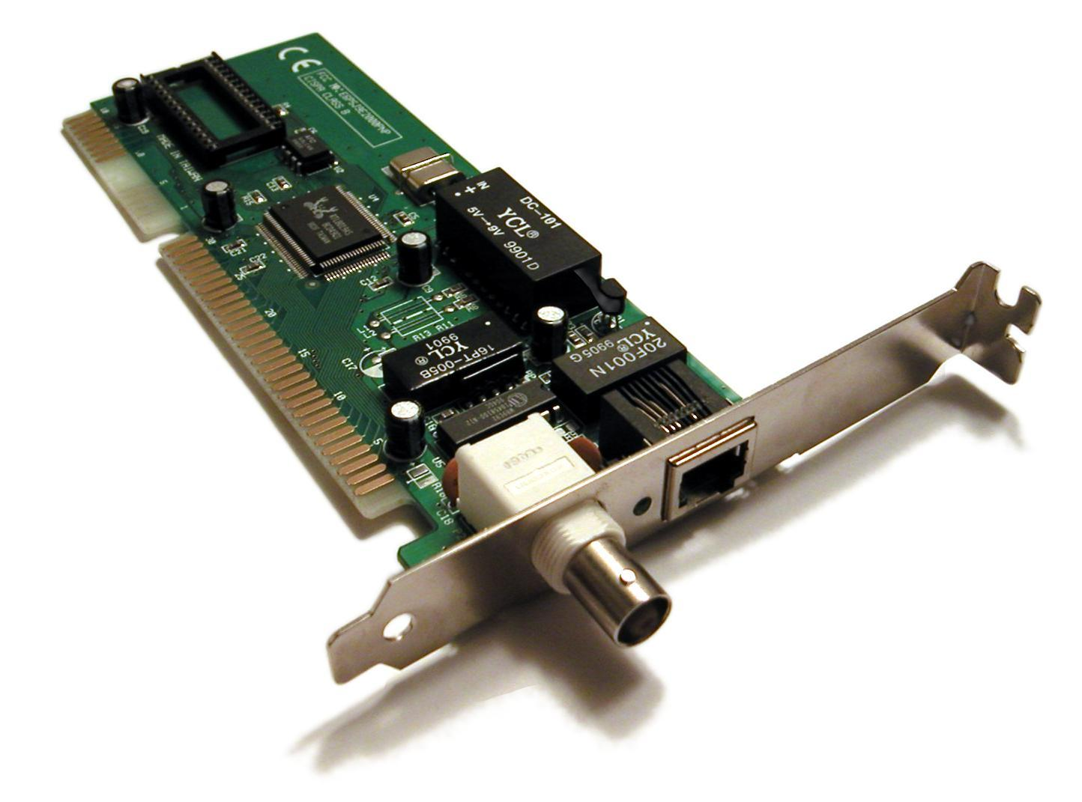
NIC functions: A network card functions as a middleman between your computer and the data network
Code of NIC processors: 00-0c29-66-87-F4
Check NIC of a computer, what is its MAC address? 00-0c29-66-87-F4
Cable to connect NIC to a network:
Type:T
Standard:10mbps

b. Hubs

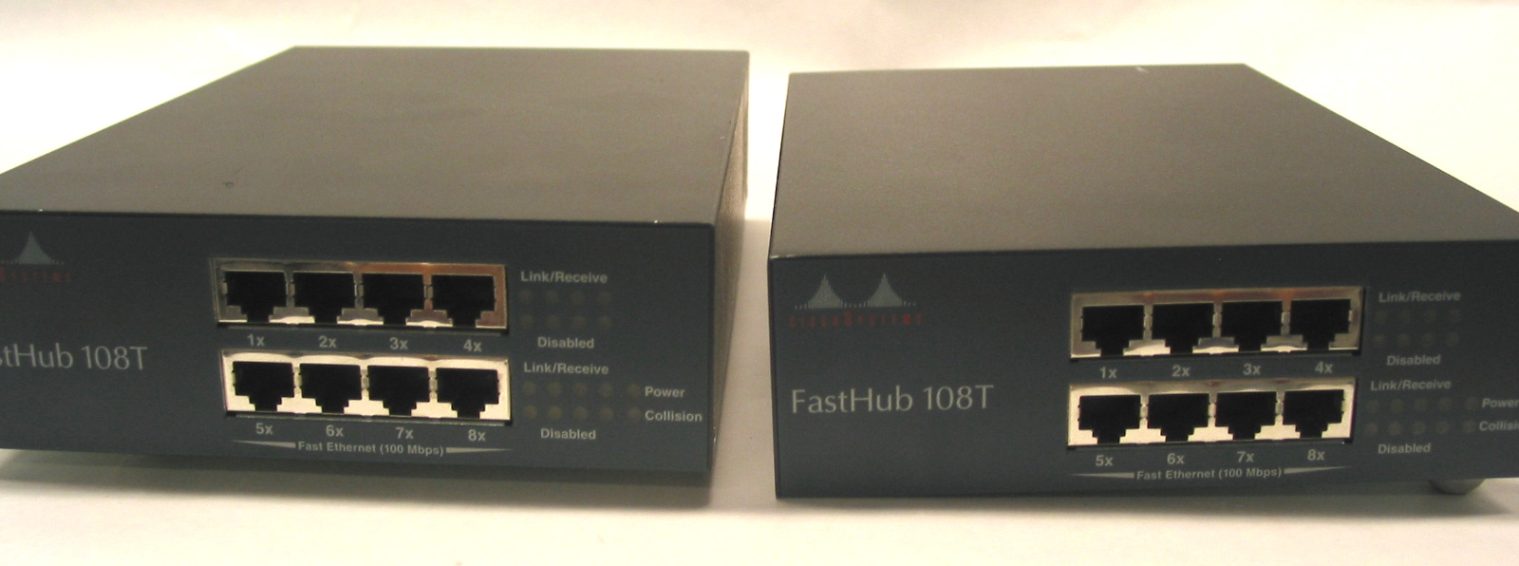

Roles of hub in a network: Hub is the simplest concentrator
Main characteristics: All information arriving on the equipment is transmitted on all the line
Weaknesses of hub: Colision is not detected
Hub ports: 100baseT and 10baseT

c. Switches
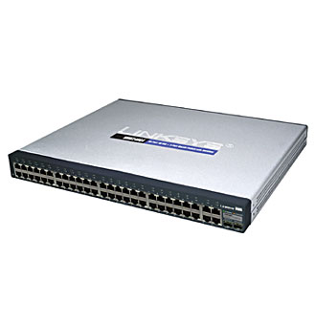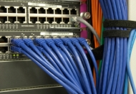
Roles of switches in a network: A switch is a device that is used at the Access or OSI Layer 2; a switch can be used to connect multiple hosts (PCs) to the network.
Main characteristics of switches: A switch prevents collisions by providing a circuit between the source and destination ports.
Differences between hubs and switches:
Weaknesses of switches: Unlike a hub, a switch forwards a message to a specific host. When any host on the network or a switch sends a message to another host on the same network or same switch, the switch receives and decodes the frames to read the physical (MAC) address portion of the message.
Switch ports: 100baseT and 10baseT

d. Routers
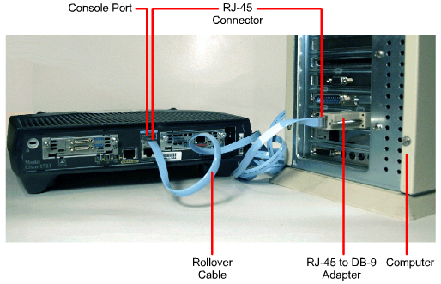

Roles of routers in a network: A router^{[a]} is a networking device that forwards data packets between computer networks.
Main characteristics of routers: Routers perform the traffic directing functions on the Internet.
Differences between routers and switches: a switch is designed to connect computers within a network, while a router is designed to connect multiple networks together.
Router ports: 100baseT and 10baseT

d. Access Points

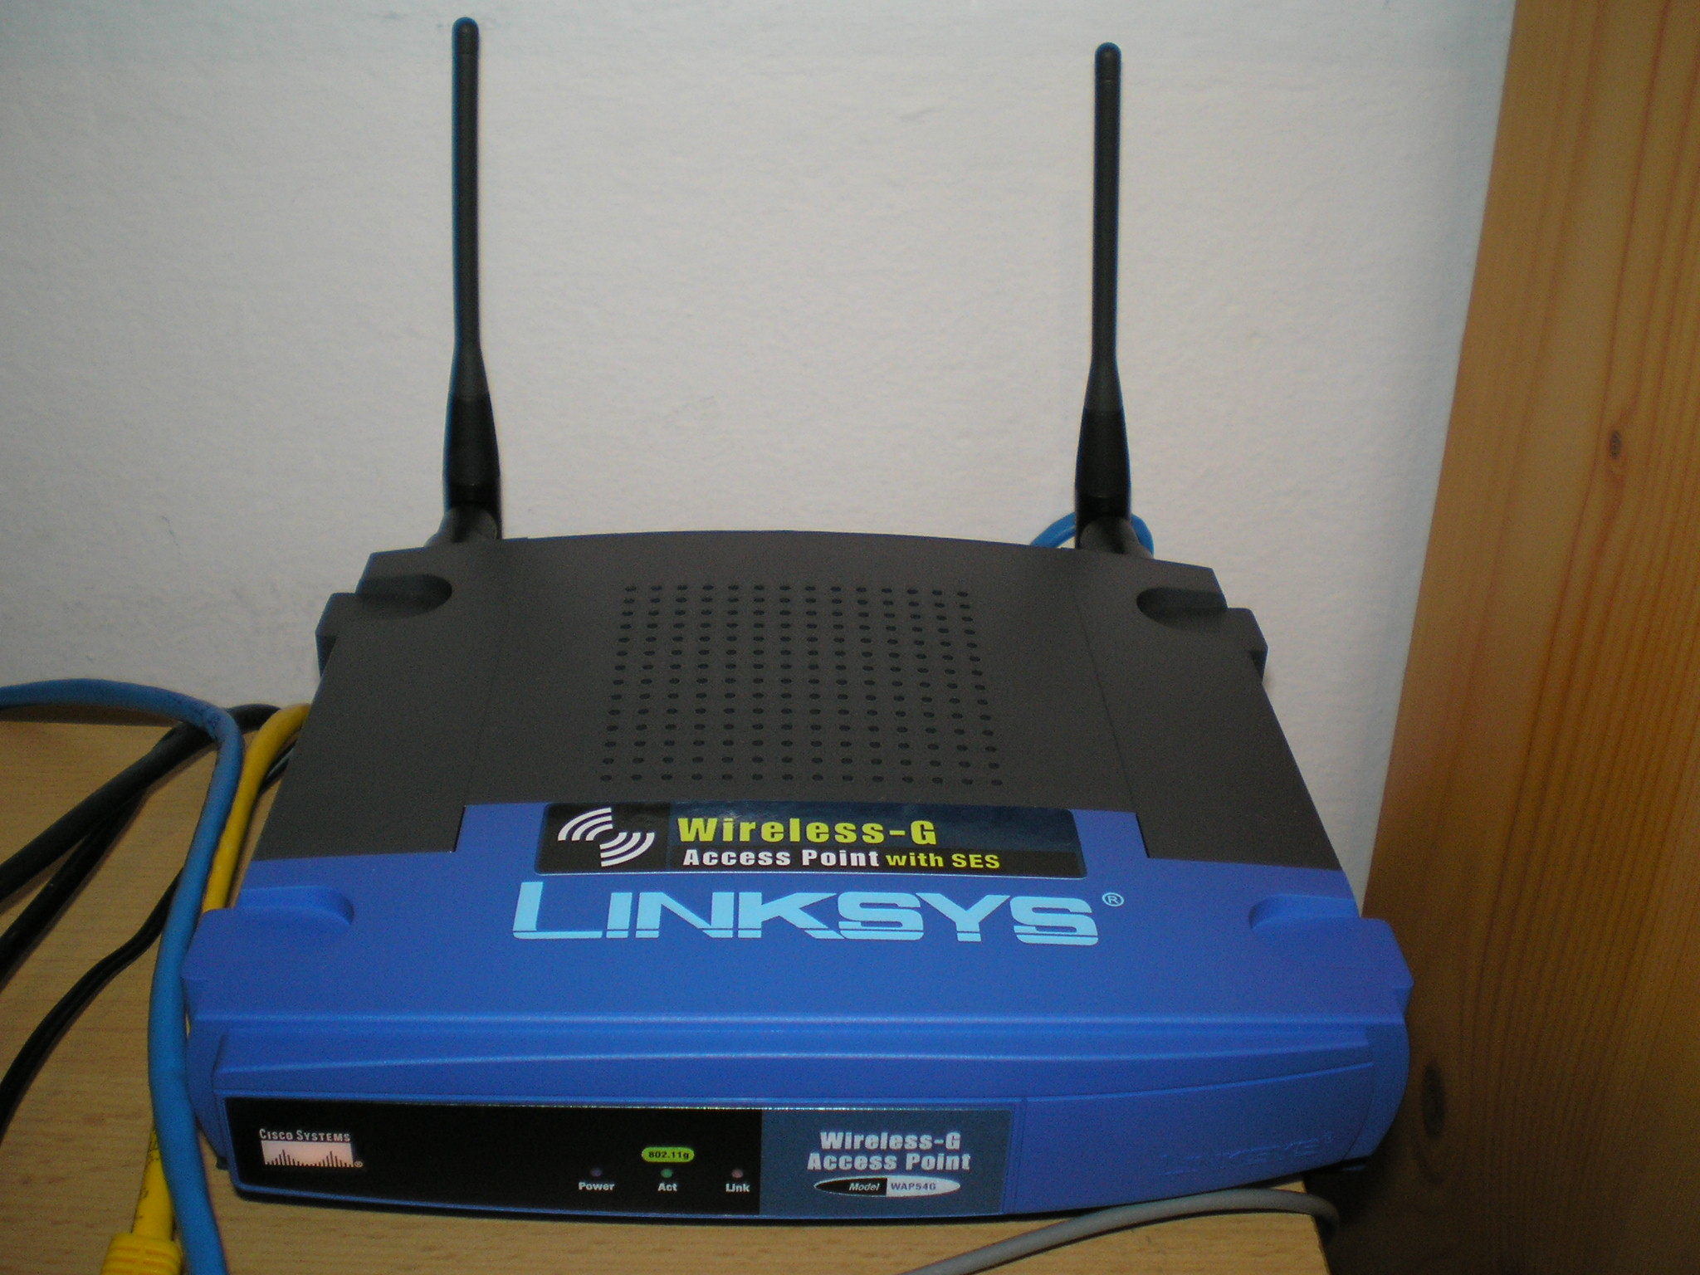
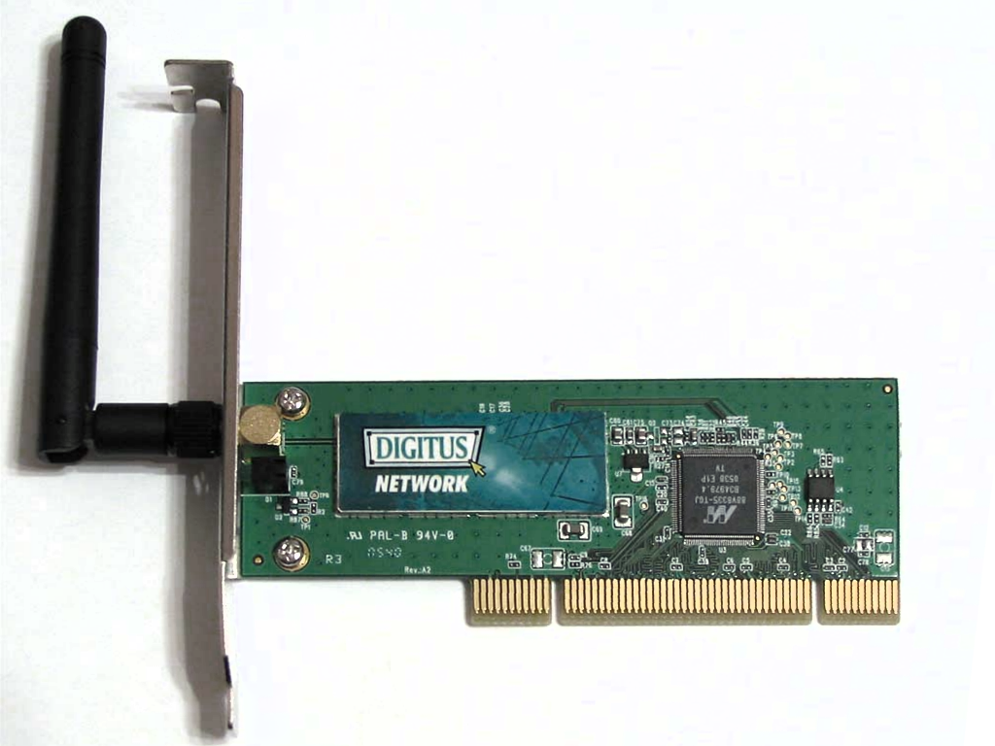

Roles of access points: An access point is a wireless network device that acts as a portal for devices to connect to a local area network.
Main characteristics of access points: Access points are used for extending the wireless coverage of an existing network and for increasing the number of users that can connect to it.
Access point’s interfaces: ath0
Compare access point and other networking devices mentioned above: The router acts as a hub that sets up a local area network and manages all of the devices and communication in it. An access point, on the other hand, is a sub-device within the local area network that provides another location for devices to connect from and enables more devices to be on the network.
Wireless routers can function as access points, but not all access points can work as routers. While routers manage local area networks, communicate with outside network systems, acquire, distribute, and dispatch data in multiple directions, establish a point of connectivity, and ensure security, access points typically only provide access to the router’s established network.

e. Modem
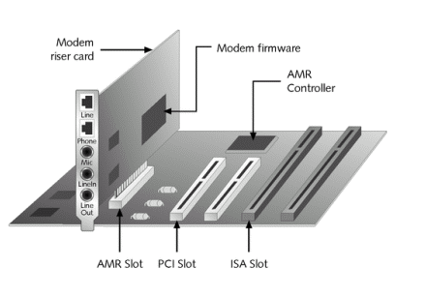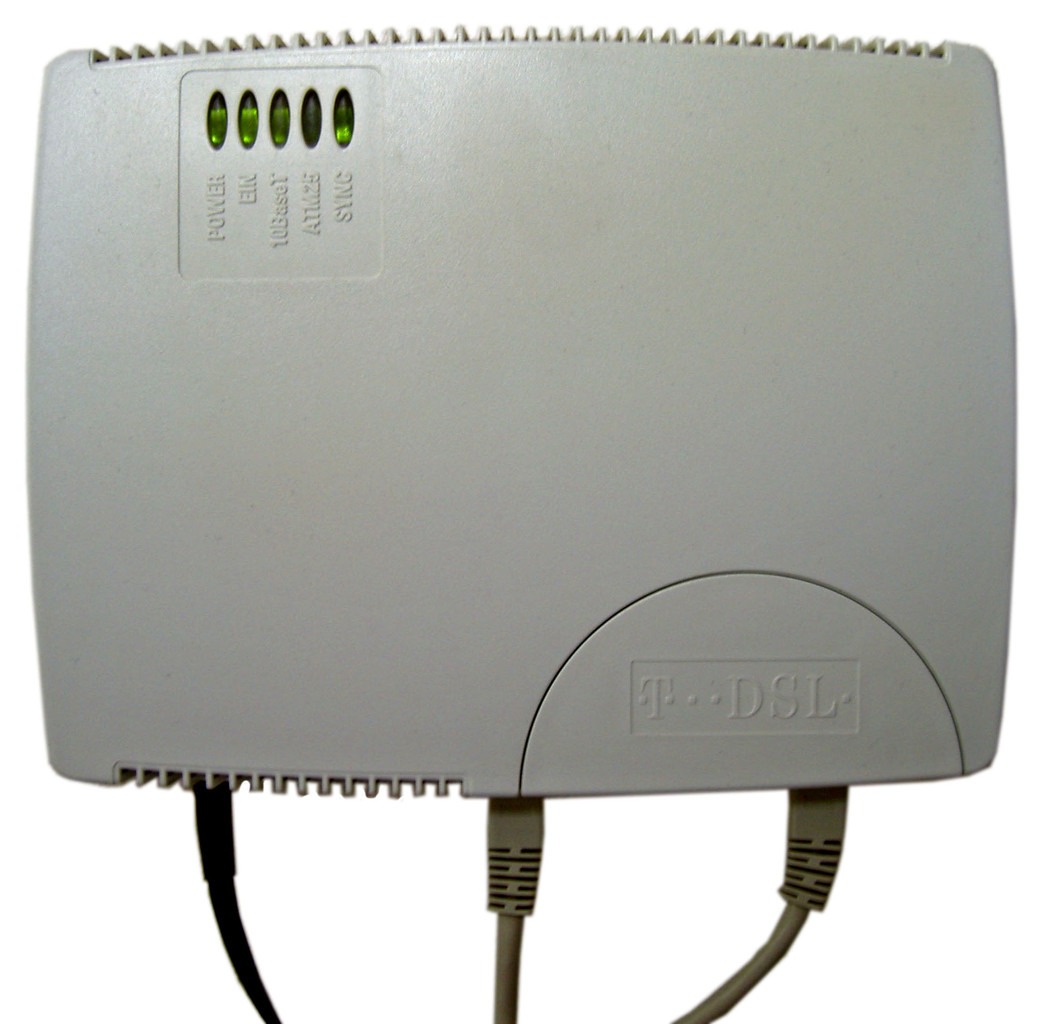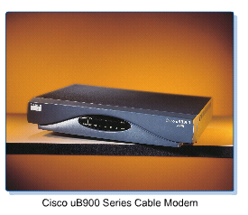

Differentiate:
- Dial-up modem is a form of Internet access that uses the facilities of the public switched telephone network (PSTN) to establish a connection to an Internet service provider (ISP) by dialing a telephone number on a conventional telephone line. Dial-up connections use modems to decode audio signals into data to send to a router or computer, and to encode signals from the latter two devices to send to another modem.
- ADSL Modem is a type of digital subscriber line (DSL) technology, a data communications technology that enables faster data transmission over copper telephone lines than a conventional voiceband modem can provide. ADSL differs from the less common symmetric digital subscriber line (SDSL). In ADSL, bandwidth and bit rate are said to be asymmetric, meaning greater toward the customer premises (downstream) than the reverse (upstream). Providers usually market ADSL as a service for consumers for Internet access for primarily downloading content from the Internet, but not serving content accessed by others.
- Cable Modem is a hardware device that allows your computer to communicate with an Internet service provider over a landline connection. It converts an analog signal to a digital signal for the purpose of granting access to broadband Internet. A cable modem works by connecting a coaxial cable and then a Cat 5 (Ethernet) cord from the modem to a computer or network router. Network routers are used to share your Internet connection between multiple computers. More modern cable modems may have the router built-in with the ability to share the connection over Wi-Fi.

For each type of modem describle its roles and characteristics:

3. Connecting network devices:

Identify the type of network cable can be used for below network connections:
a) Computer and hub straight-through cables
b) Computer and switch straight-through cables
c) Computer and router straight-through cables

d) Computer hub and hub Crossover cables
e) Hub and switch straight-through cables
f) Hub and router straight-through cables

g) Switch and switch Crossover cables
h) Swith and router straight-through cables
k) Router and router Crossover cables

